**Question 1-4:**

To begin with, let me describe the system which we are going to use. We are going to work with the ball-roller-machine which looks like a round track, but with specified amount of sensors and pneumatic systems which allow the ball to rotate up and down around this system. In pair with this system we use a PLC controller “Allen-Bradley 830 series revision 2” and program it with Ladder diagram. Each sensor and piston has a specified address which we have to use in our program. On the picture below, you could see this specification.

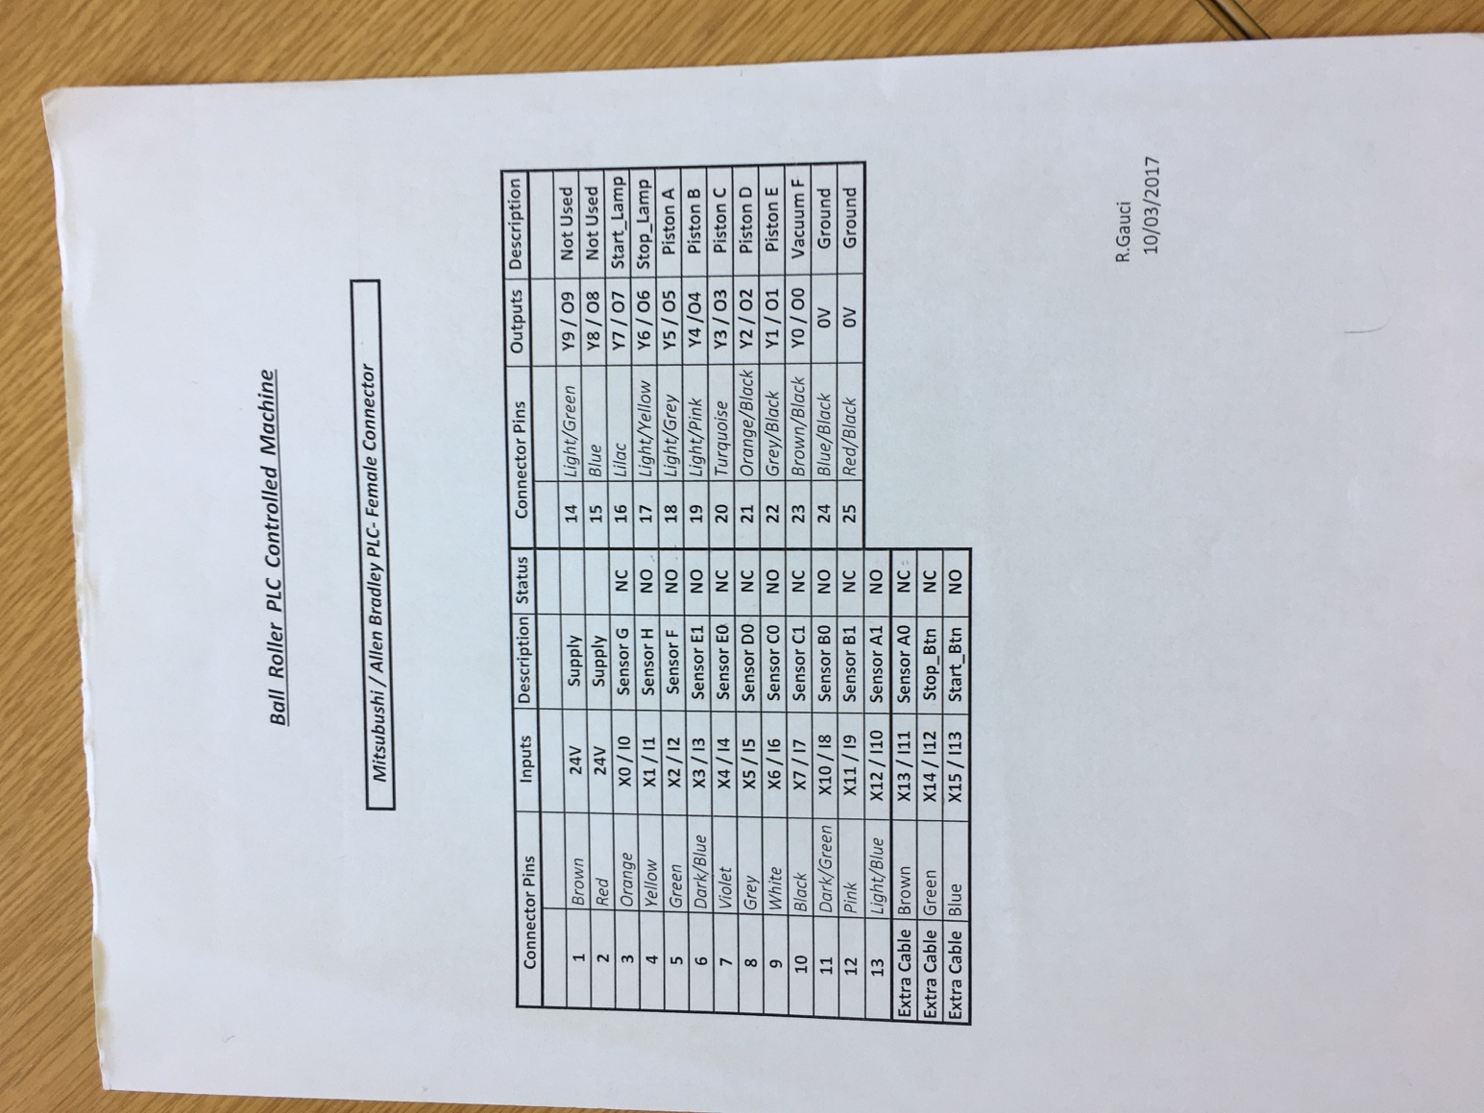

As you can see, all sensors and pistons are specified even bulbs for START/STOP push buttons.

On the next pictures, I’m going to show you how our system looks like.

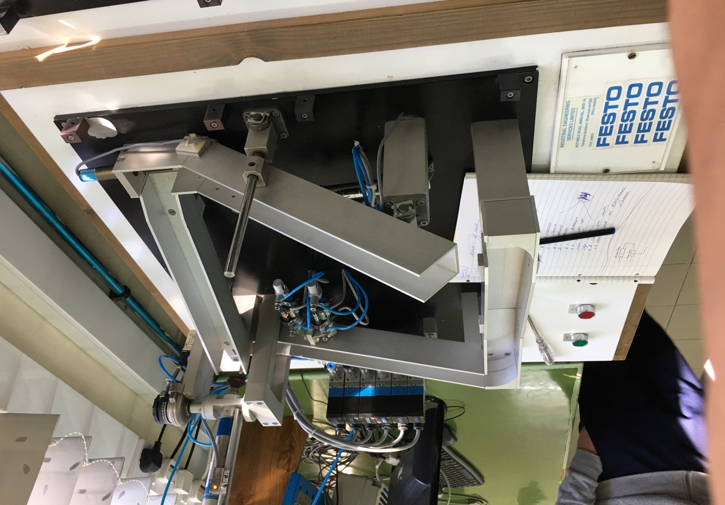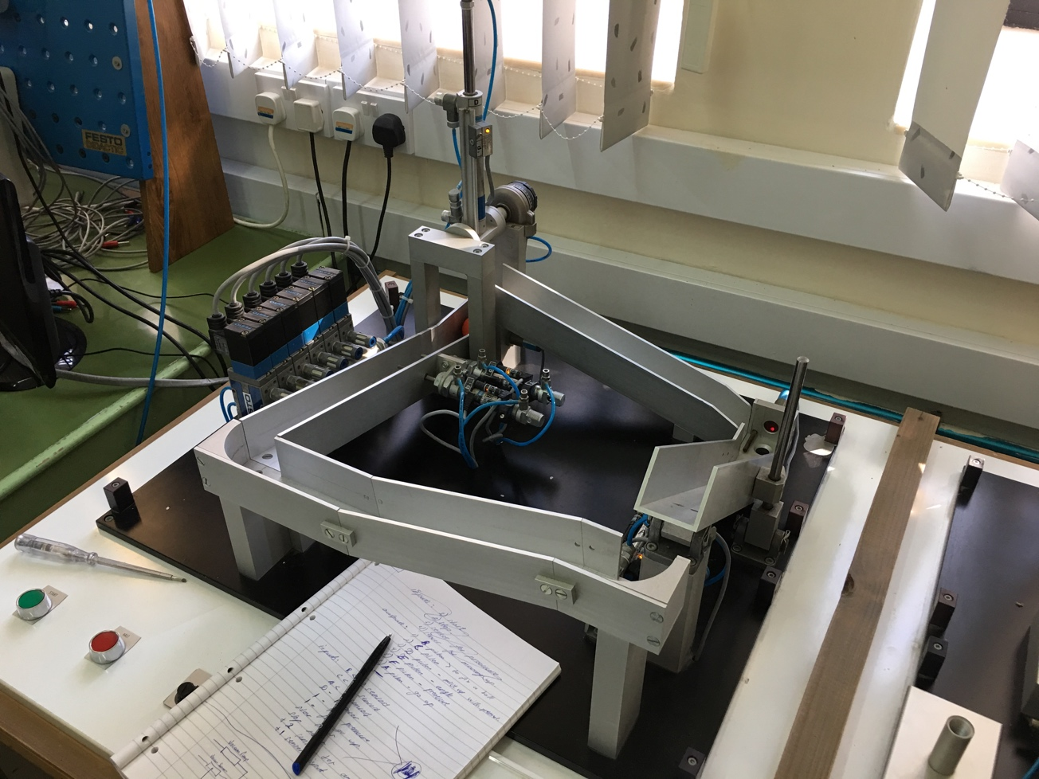

As you could see, there are a lot of different sensors and pistons in our system:

* Pistons to split up a balls at the beginning;
* Sensor for detection of the ball in the left top corner;
* Piston for moving the tube down to the ball;
* Sensor which detects that the tube is in correct position and is ready to activate the vacuum;
* Vacuum to pull up the ball;
* Sensor for checking the angle of the piston with ball;
* Piston which rotates the piston with the ball;
* Sensor which detects that the ball is in the top right corner;
* Piston to push up the whole branch and makes the ball to rotate to the starting point;
* And of course all pistons has their own sensors which help us to control them.

There are more details on the pictures below.

It’s an **opto-electronic proximity sensors** (which are located in the top left and right corners and helps the system to detect the ball).

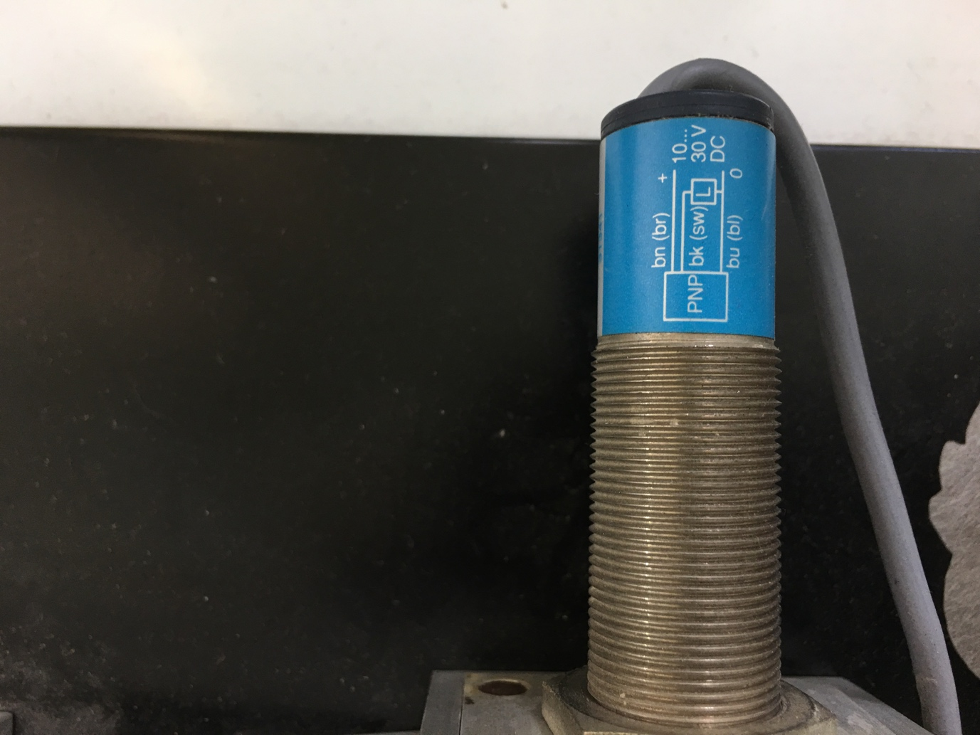

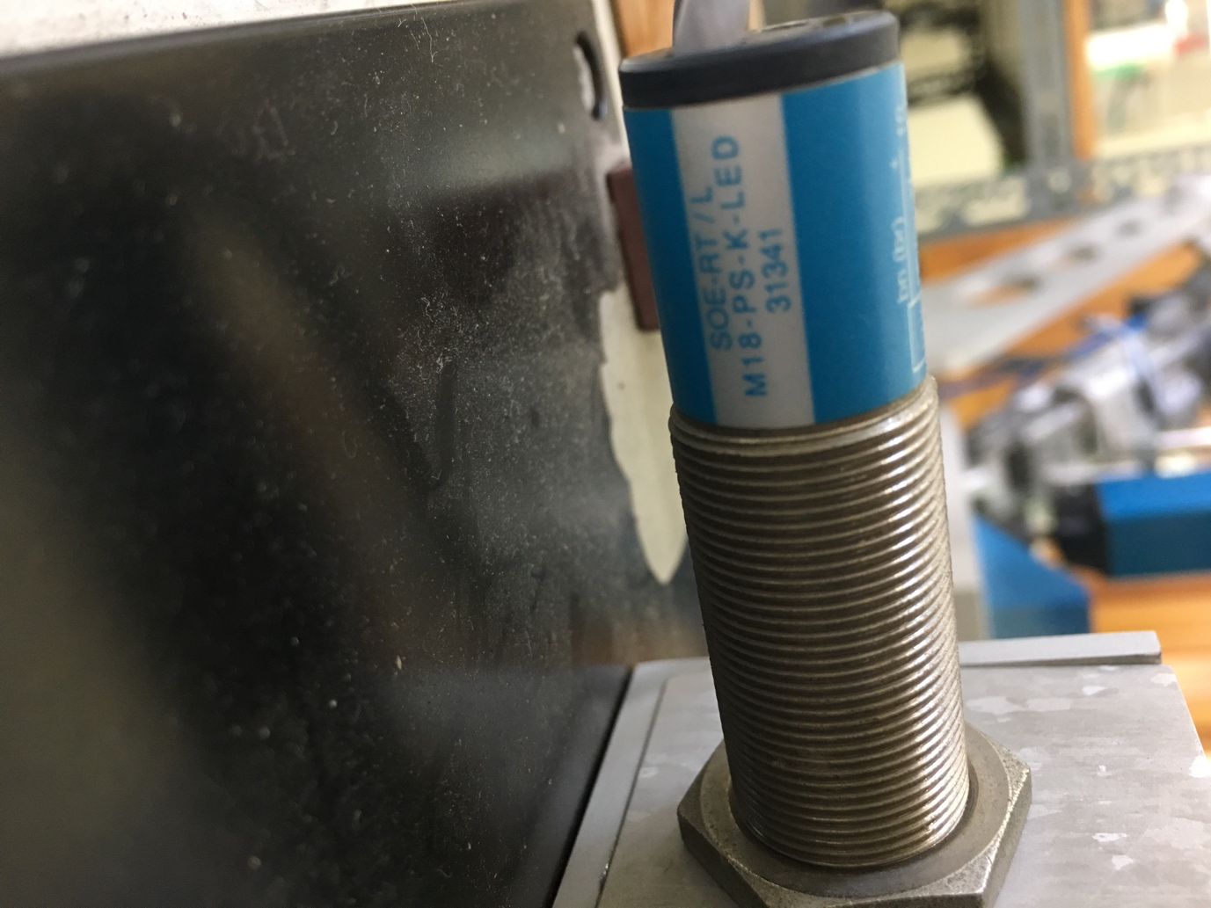

Here is a short description of this sensors

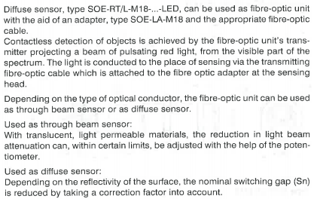

And the possible way of use.

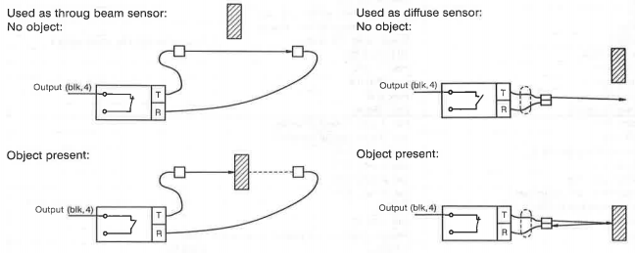

It is the sensor which we used for detection of the up and down position of the piston. It’s a proximity sensor (magnetic reed measuring principle).

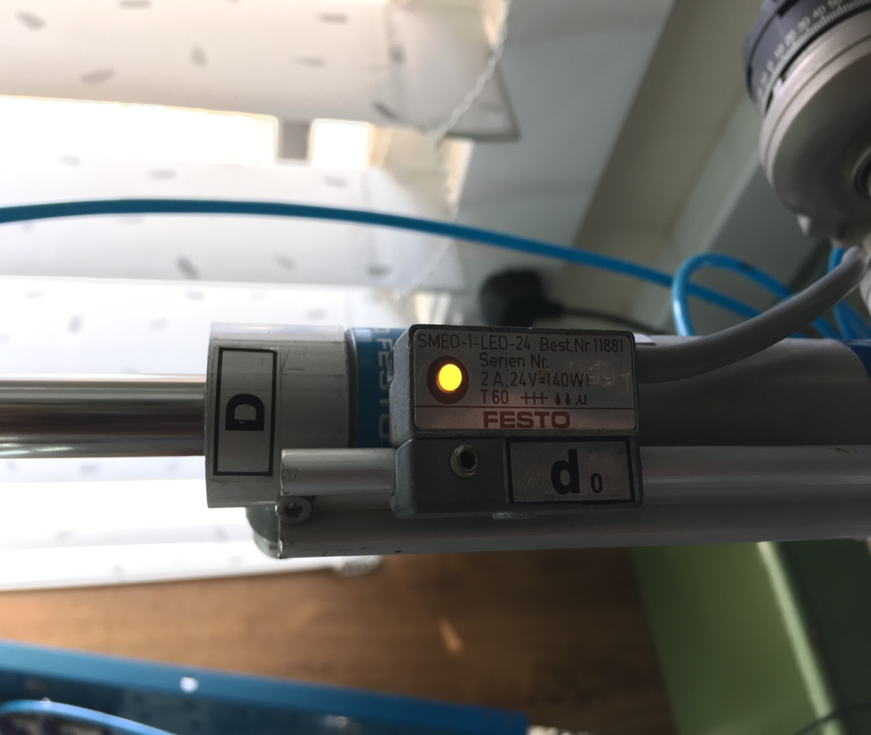

Here you could see the function and dimension parameters of the sensor.

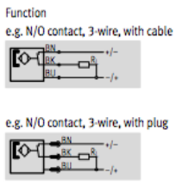

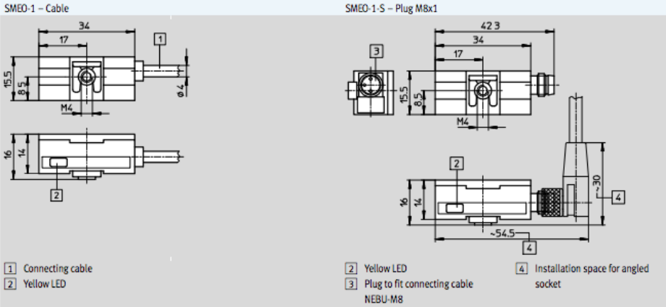

On the picture below, you could notice similar sensors for the pistons which is located at the Starting position.

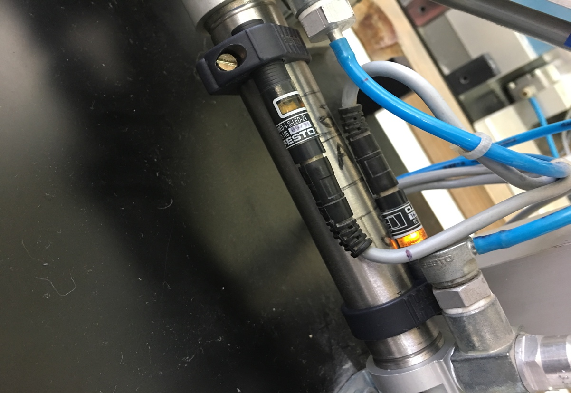

As we could see, there are valves which we use to control pistons in the the system. There is one extra valve under the system which controls the vacuum.

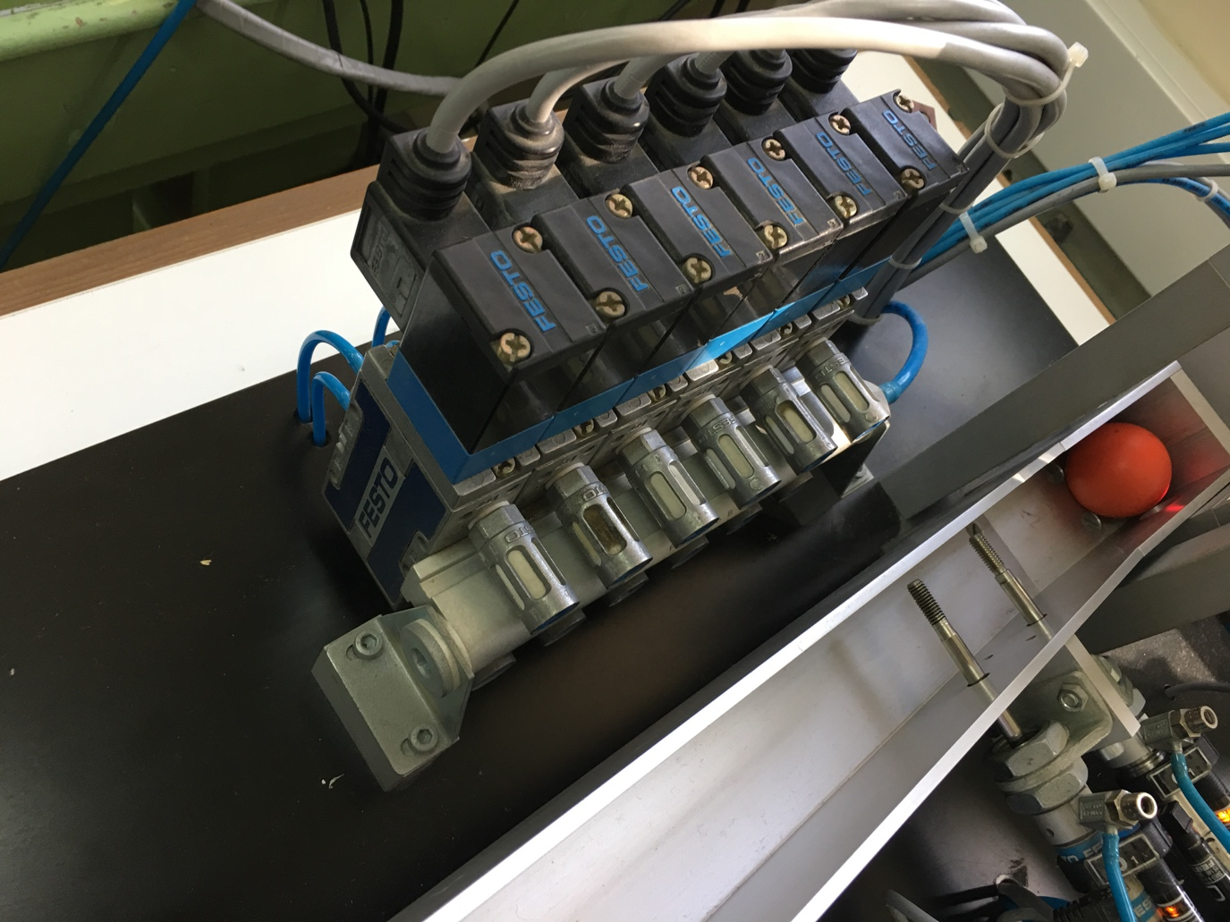

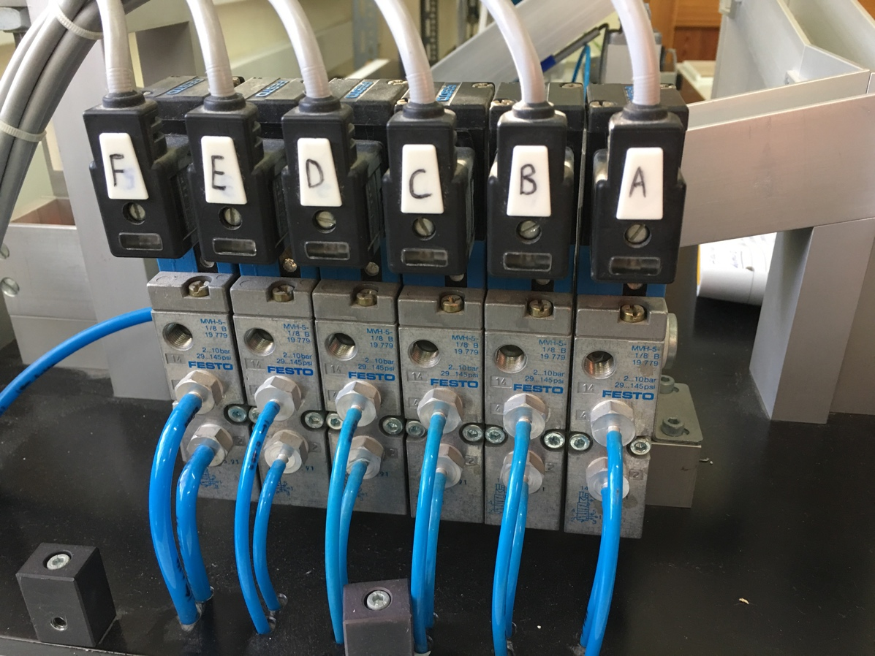

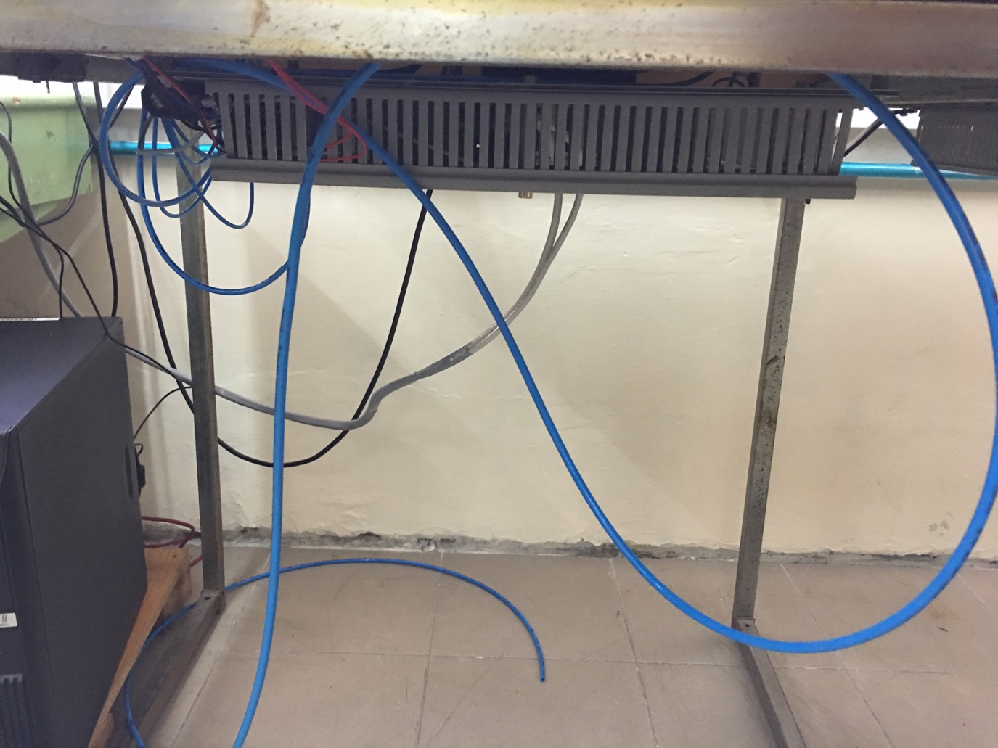

PLC controller “Allen-Bradley 830 series revision 2”.

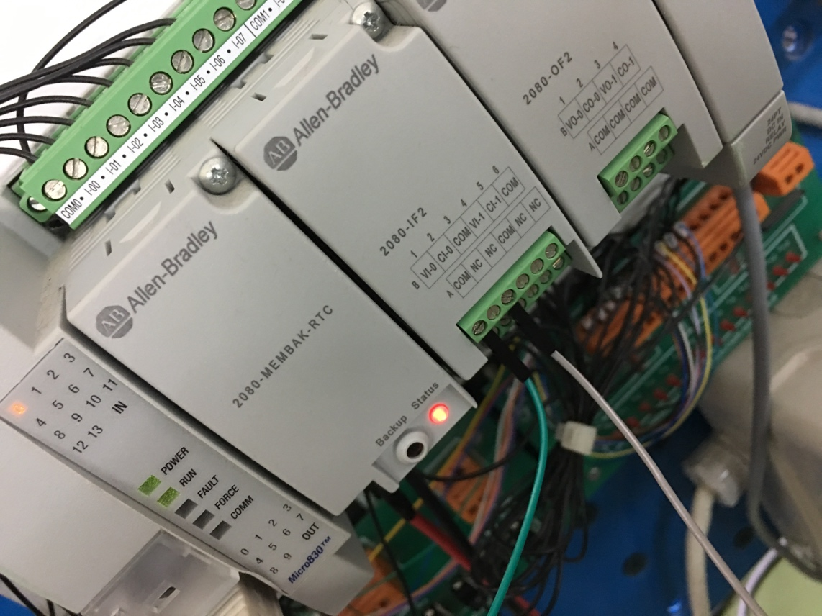

**Some characteristic of our PLC:**

* Offers 10-point, 16-point, 24-point, and 48-point controllers;
* Includes 100KHz speed high-speed counter (HSC) on 24V DC models;
* Supports as many as five Micro800® Plug-in Modules;
* Provides embedded motion capabilities by supporting as many as three axes with Pulse Train Outputs (PTO);
* Provides embedded communications via USB programming port and non-isolated serial port (for RS-232 and RS-485 communications);
* Operates in -20…65 °C (-4…149 °F) temperatures.

Let me show you the software part with Ladder diagram of the program.

Controller.Micro830.Micro830.Prog1

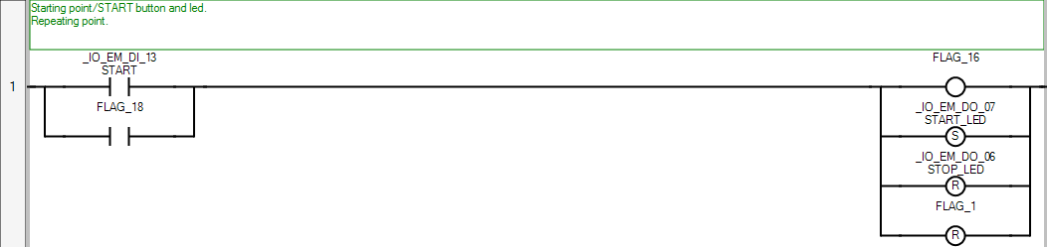

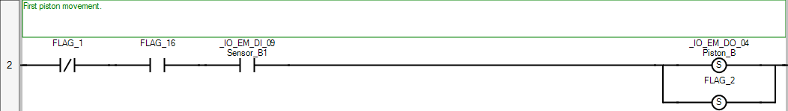

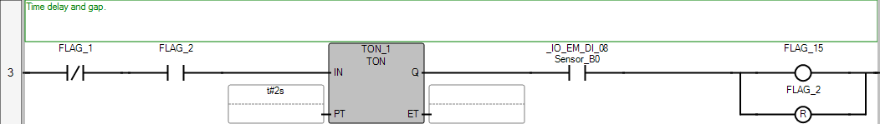

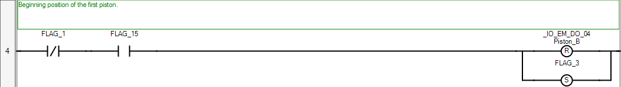

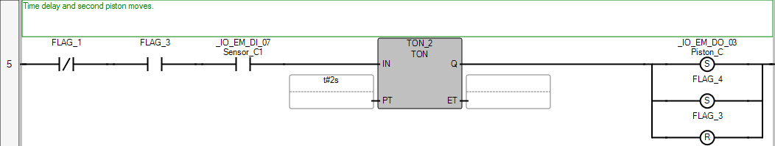

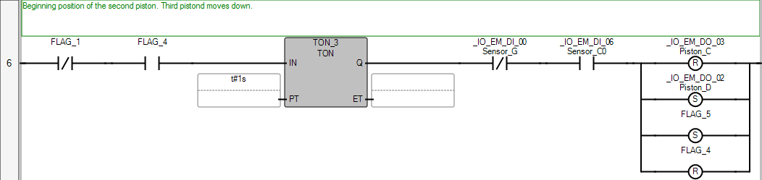

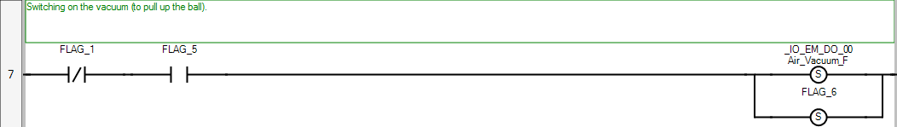

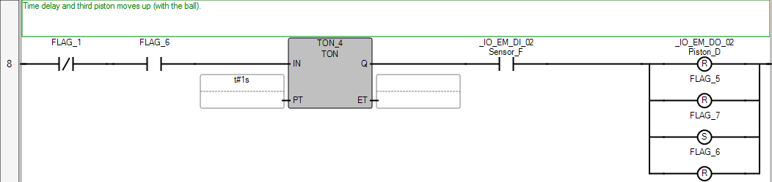

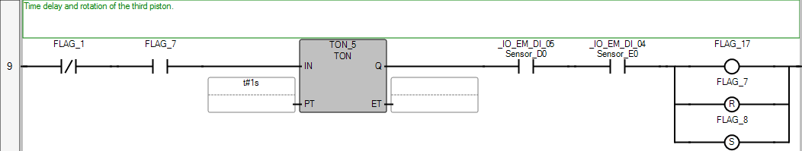



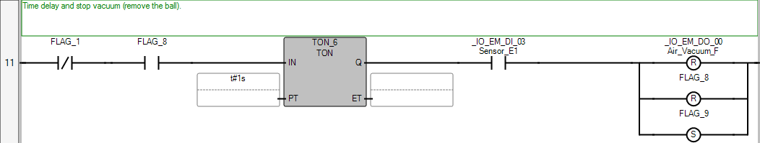

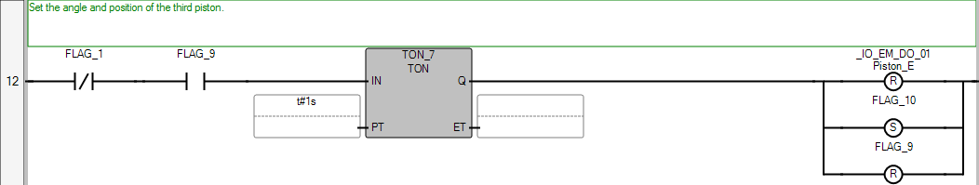

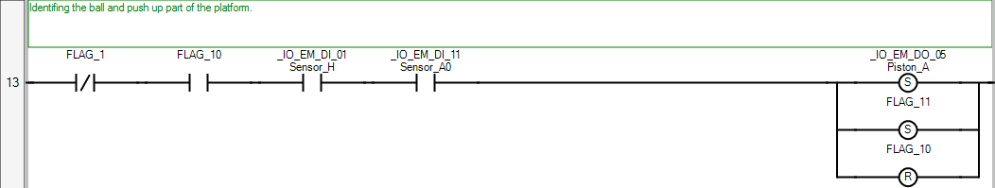

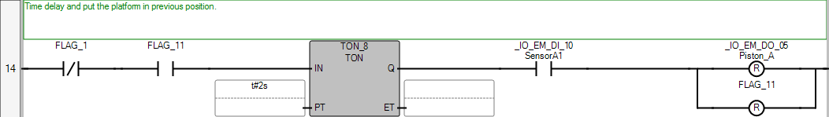



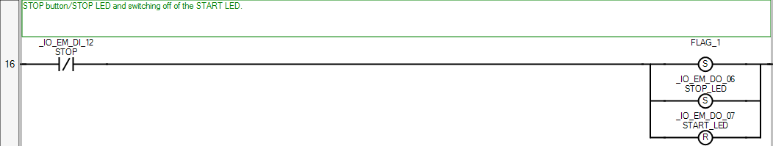

POU Prog1

The POU defines 26 variable(s).

Variable FLAG_1

(* *)

Direction: Var

Data type: BOOL

Attribute: Read/Write

Variable FLAG_2

(* *)

Direction: Var

Data type: BOOL

Attribute: Read/Write

Variable FLAG_3

(* *)

Direction: Var

Data type: BOOL

Attribute: Read/Write

Variable FLAG_4

(* *)

Direction: Var

Data type: BOOL

Attribute: Read/Write

Variable FLAG_5

(* *)

Direction: Var

Data type: BOOL

Attribute: Read/Write

Variable FLAG_6

(* *)

Direction: Var

Data type: BOOL

Attribute: Read/Write

Variable FLAG_7

(* *)

Direction: Var

Data type: BOOL

Attribute: Read/Write

Variable FLAG_8

(* *)

Direction: Var

Data type: BOOL

Attribute: Read/Write

Variable FLAG_9

(* *)

Direction: Var

Data type: BOOL

Attribute: Read/Write

Variable FLAG_10

(* *)

Direction: Var

Data type: BOOL

Attribute: Read/Write

Variable FLAG_11

(* *)

Direction: Var

Data type: BOOL

Attribute: Read/Write

Variable FLAG_12

(* *)

Direction: Var

Data type: BOOL

Attribute: Read/Write

Variable FLAG_13

(* *)

Direction: Var

Data type: BOOL

Attribute: Read/Write

Variable FLAG_14

(* *)

Direction: Var

Data type: BOOL

Attribute: Read/Write

Variable FLAG_15

(* *)

Direction: Var

Data type: BOOL

Attribute: Read/Write

Variable FLAG_16

(* *)

Direction: Var

Data type: BOOL

Attribute: Read/Write

Variable FLAG_17

(* *)

Direction: Var

Data type: BOOL

Attribute: Read/Write

Variable FLAG_18

(* *)

Direction: Var

Data type: BOOL

Attribute: Read/Write

Variable TON_1

(* *)

Direction: Var

Data type: TON

Attribute: Read/Write

Variable TON_2

(* *)

Direction: Var

Data type: TON

Attribute: Read/Write

Variable TON_3

(* *)

Direction: Var

Data type: TON

Attribute: Read/Write

Variable TON_4

(* *)

Direction: Var

Data type: TON

Attribute: Read/Write

Variable TON_5

(* *)

Direction: Var

Data type: TON

Attribute: Read/Write

Variable TON_6

(* *)

Direction: Var

Data type: TON

Attribute: Read/Write

Variable TON_7

(* *)

Direction: Var

Data type: TON

Attribute: Read/Write

Variable TON_8

(* *)

Direction: Var

Data type: TON

Attribute: Read/Write

Configuration Micro830

The detailed description of the configuration goes here

Resource Micro830

(* *)

Status: Readable, Modifiable, Deletable

The resource defines 44 variable(s).

Variable _IO_EM_DO_00

(* *)

Direction: VarDirectlyRepresented

Alias: Air_Vacuum_F

Data type: BOOL

Attribute: Read/Write

Direct variable (Channel): %QX0.0.0

Variable _IO_EM_DO_01

(* *)

Direction: VarDirectlyRepresented

Alias: Piston_E

Data type: BOOL

Attribute: Read/Write

Direct variable (Channel): %QX0.0.1

Variable _IO_EM_DO_02

(* *)

Direction: VarDirectlyRepresented

Alias: Piston_D

Data type: BOOL

Attribute: Read/Write

Direct variable (Channel): %QX0.0.2

Variable _IO_EM_DO_03

(* *)

Direction: VarDirectlyRepresented

Alias: Piston_C

Data type: BOOL

Attribute: Read/Write

Direct variable (Channel): %QX0.0.3

Variable _IO_EM_DO_04

(* *)

Direction: VarDirectlyRepresented

Alias: Piston_B

Data type: BOOL

Attribute: Read/Write

Direct variable (Channel): %QX0.0.4

Variable _IO_EM_DO_05

(* *)

Direction: VarDirectlyRepresented

Alias: Piston_A

Data type: BOOL

Attribute: Read/Write

Direct variable (Channel): %QX0.0.5

Variable _IO_EM_DO_06

(* *)

Direction: VarDirectlyRepresented

Alias: STOP_LED

Data type: BOOL

Attribute: Read/Write

Direct variable (Channel): %QX0.0.6

Variable _IO_EM_DO_07

(* *)

Direction: VarDirectlyRepresented

Alias: START_LED

Data type: BOOL

Attribute: Read/Write

Direct variable (Channel): %QX0.0.7

Variable _IO_EM_DO_08

(* *)

Direction: VarDirectlyRepresented

Data type: BOOL

Attribute: Read/Write

Direct variable (Channel): %QX0.0.8

Variable _IO_EM_DO_09

(* *)

Direction: VarDirectlyRepresented

Data type: BOOL

Attribute: Read/Write

Direct variable (Channel): %QX0.0.9

Variable _IO_EM_DI_00

(* *)

Direction: VarDirectlyRepresented

Alias: Sensor_G

Data type: BOOL

Attribute: Read

Direct variable (Channel): %IX0.1.0

Variable _IO_EM_DI_01

(* *)

Direction: VarDirectlyRepresented

Alias: Sensor_H

Data type: BOOL

Attribute: Read

Direct variable (Channel): %IX0.1.1

Variable _IO_EM_DI_02

(* *)

Direction: VarDirectlyRepresented

Alias: Sensor_F

Data type: BOOL

Attribute: Read

Direct variable (Channel): %IX0.1.2

Variable _IO_EM_DI_03

(* *)

Direction: VarDirectlyRepresented

Alias: Sensor_E1

Data type: BOOL

Attribute: Read

Direct variable (Channel): %IX0.1.3

Variable _IO_EM_DI_04

(* *)

Direction: VarDirectlyRepresented

Alias: Sensor_E0

Data type: BOOL

Attribute: Read

Direct variable (Channel): %IX0.1.4

Variable _IO_EM_DI_05

(* *)

Direction: VarDirectlyRepresented

Alias: Sensor_D0

Data type: BOOL

Attribute: Read

Direct variable (Channel): %IX0.1.5

Variable _IO_EM_DI_06

(* *)

Direction: VarDirectlyRepresented

Alias: Sensor_C0

Data type: BOOL

Attribute: Read

Direct variable (Channel): %IX0.1.6

Variable _IO_EM_DI_07

(* *)

Direction: VarDirectlyRepresented

Alias: Sensor_C1

Data type: BOOL

Attribute: Read

Direct variable (Channel): %IX0.1.7

Variable _IO_EM_DI_08

(* *)

Direction: VarDirectlyRepresented

Alias: Sensor_B0

Data type: BOOL

Attribute: Read

Direct variable (Channel): %IX0.1.8

Variable _IO_EM_DI_09

(* *)

Direction: VarDirectlyRepresented

Alias: Sensor_B1

Data type: BOOL

Attribute: Read

Direct variable (Channel): %IX0.1.9

Variable _IO_EM_DI_10

(* *)

Direction: VarDirectlyRepresented

Alias: SensorA1

Data type: BOOL

Attribute: Read

Direct variable (Channel): %IX0.1.10

Variable _IO_EM_DI_11

(* *)

Direction: VarDirectlyRepresented

Alias: Sensor_A0

Data type: BOOL

Attribute: Read

Direct variable (Channel): %IX0.1.11

Variable _IO_EM_DI_12

(* *)

Direction: VarDirectlyRepresented

Alias: STOP

Data type: BOOL

Attribute: Read

Direct variable (Channel): %IX0.1.12

Variable _IO_EM_DI_13

(* *)

Direction: VarDirectlyRepresented

Alias: START

Data type: BOOL

Attribute: Read

Direct variable (Channel): %IX0.1.13

Variable __SYSVA_CYCLECNT

(* Cycle counter *)

Direction: VarGlobal

Data type: DINT

Attribute: Read

Variable __SYSVA_CYCLEDATE

(* Timestamp of the beginning of the cycle in milliseconds (ms) *)

Direction: VarGlobal

Data type: TIME

Attribute: Read

Variable __SYSVA_KVBPERR

(* Kernel variable binding producing error (production error) *)

Direction: VarGlobal

Data type: BOOL

Attribute: Read

Variable __SYSVA_KVBCERR

(* Kernel variable binding consuming error (consumption error) *)

Direction: VarGlobal

Data type: BOOL

Attribute: Read/Write

Variable __SYSVA_RESNAME

(* Resource name (max length=255) *)

Direction: VarGlobal

Data type: STRING

Attribute: Read

Variable __SYSVA_SCANCNT

(* Input scan counter *)

Direction: VarGlobal

Data type: DINT

Attribute: Read

Variable __SYSVA_TCYCYCTIME

(* Programmed cycle time *)

Direction: VarGlobal

Data type: TIME

Attribute: Read/Write

Variable __SYSVA_TCYCURRENT

(* Current cycle time *)

Direction: VarGlobal

Data type: TIME

Attribute: Read

Variable __SYSVA_TCYMAXIMUM

(* Maximum cycle time since last start *)

Direction: VarGlobal

Data type: TIME

Attribute: Read

Variable __SYSVA_TCYOVERFLOW

(* Number of cycle overflows *)

Direction: VarGlobal

Data type: DINT

Attribute: Read

Variable __SYSVA_RESMODE

(* Resource execution mode *)

Direction: VarGlobal

Data type: SINT

Attribute: Read

Variable __SYSVA_CCEXEC

(* Execute one cycle when application is in cycle to cycle mode *)

Direction: VarGlobal

Data type: BOOL

Attribute: Read/Write

Variable __SYSVA_REMOTE

(* Remote status *)

Direction: VarGlobal

Data type: BOOL

Attribute: Read

Variable __SYSVA_SUSPEND_ID

(* Last Suspend ID *)

Direction: VarGlobal

Data type: UINT

Attribute: Read

Variable __SYSVA_TCYWDG

(* Software Watchdog *)

Direction: VarGlobal

Data type: UDINT

Attribute: Read/Write

Variable __SYSVA_MAJ_ERR_HALT

(* Major Error Halted status *)

Direction: VarGlobal

Data type: BOOL

Attribute: Read

Variable __SYSVA_ABORT_CYCLE

(* Aborting Cycle *)

Direction: VarGlobal

Data type: BOOL

Attribute: Read

Variable __SYSVA_FIRST_SCAN

(* First scan bit *)

Direction: VarGlobal

Data type: BOOL

Attribute: Read

Variable __SYSVA_USER_DATA_LOST

(* User data lost *)

Direction: VarGlobal

Data type: BOOL

Attribute: Read/Write

Variable __SYSVA_POWERUP_BIT

(* Power-up bit *)

Direction: VarGlobal

Data type: BOOL

Attribute: Read

The basic principle which I follow in my program is: using of timers TON, sensors and flags as an input conditions for activation the timer and particular action, and flags to move to the next condition and set/reset coils for correct work with sensors and pistons. The main thing on which we have to consider our attention in Ladder diagram programming is logic.

Now, let me show you, how the system operates.

At the beginning we have to press the green START button.

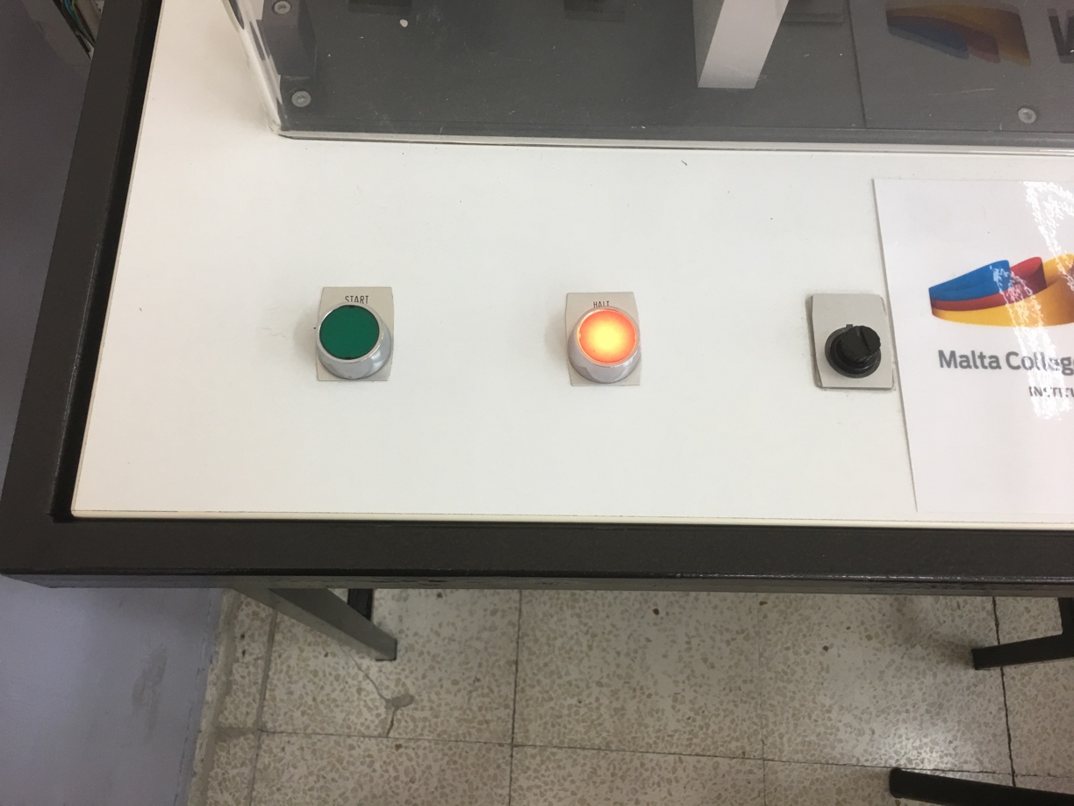

The the START button will start to light with a green color.

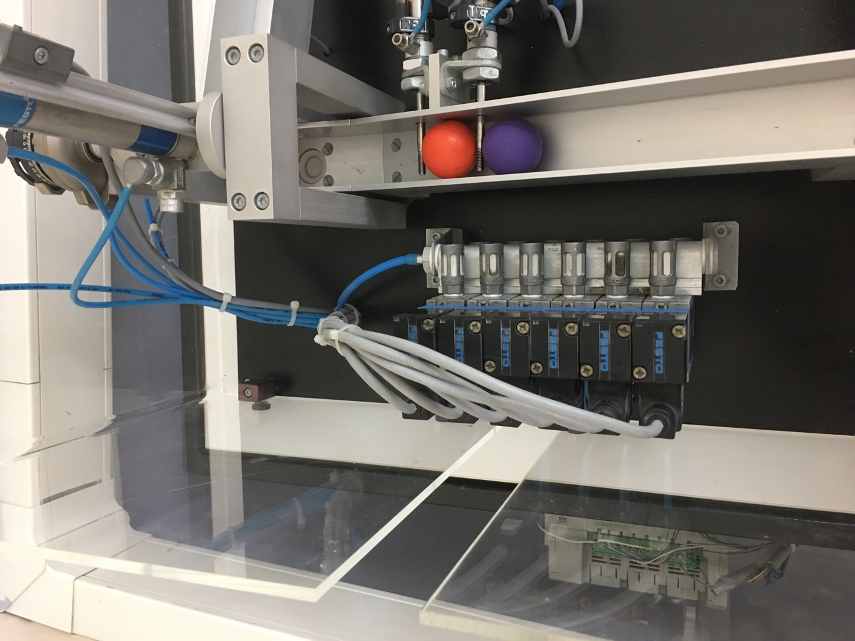

After that the first piston will go out and the ball will roll down and stop in front of the next piston. Piston 1 will close and then piston 2 will open and the ball will go down till the end.

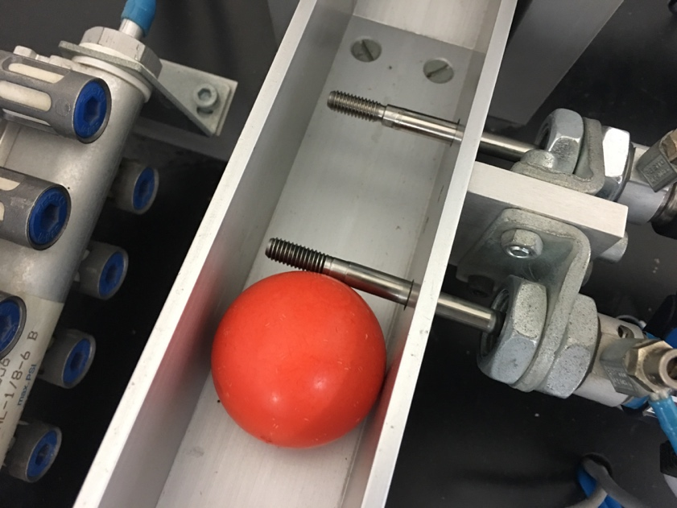

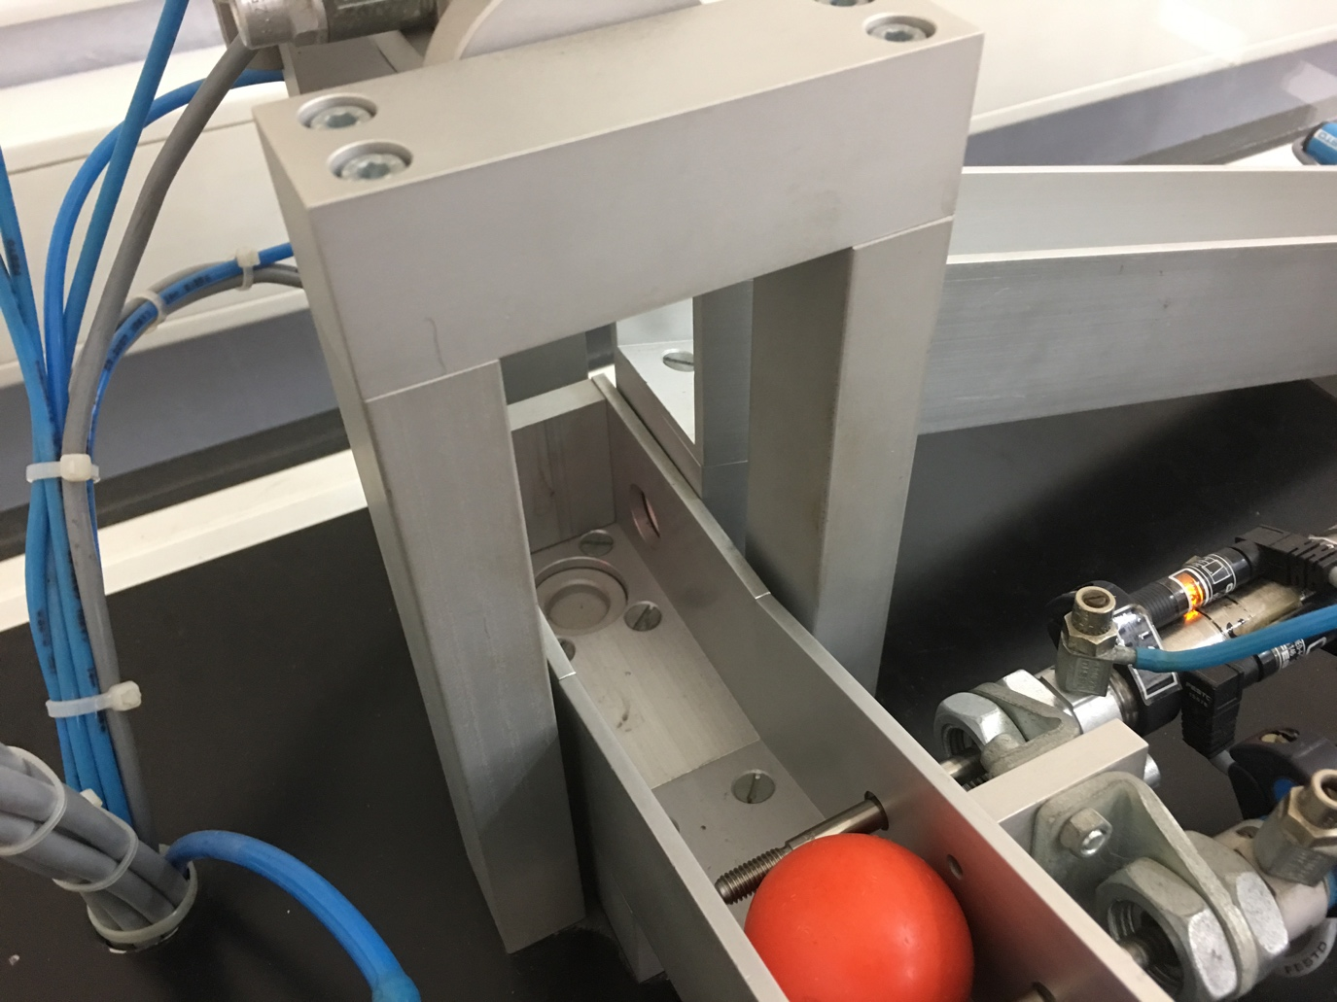

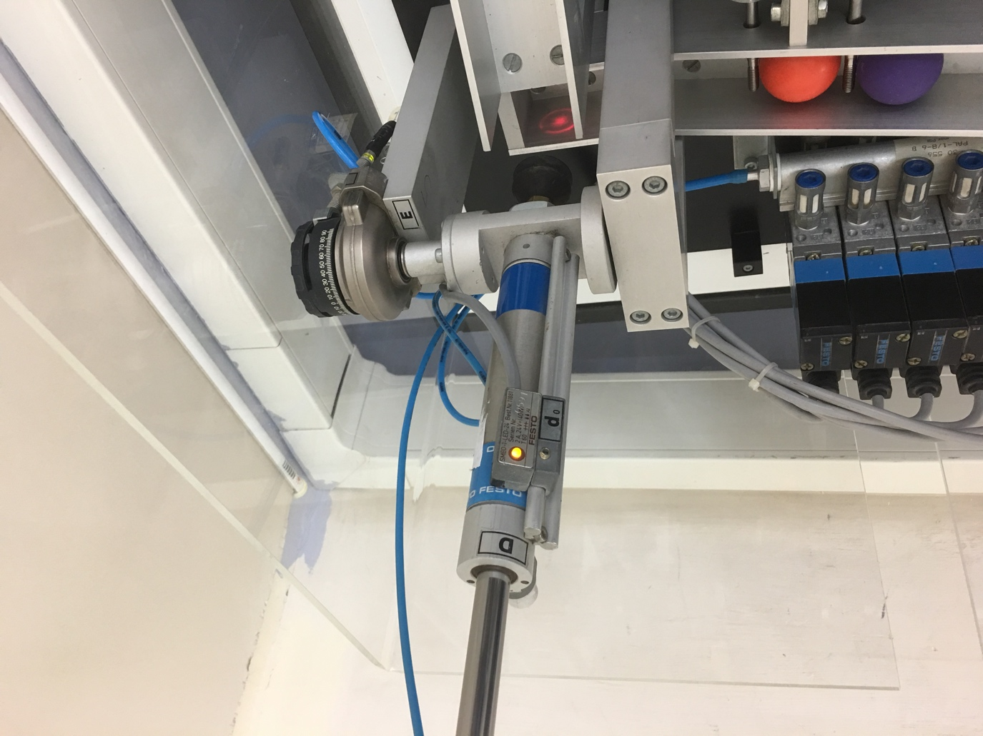

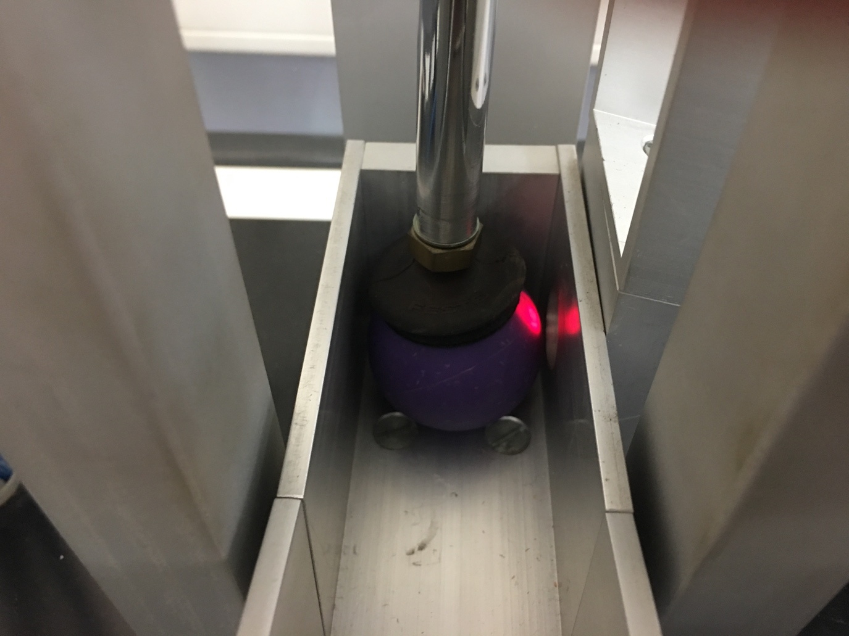

After the detection of the ball, the piston will go down take it with help of vacuum and pull it up, than change the angle and drop it on the next branch.

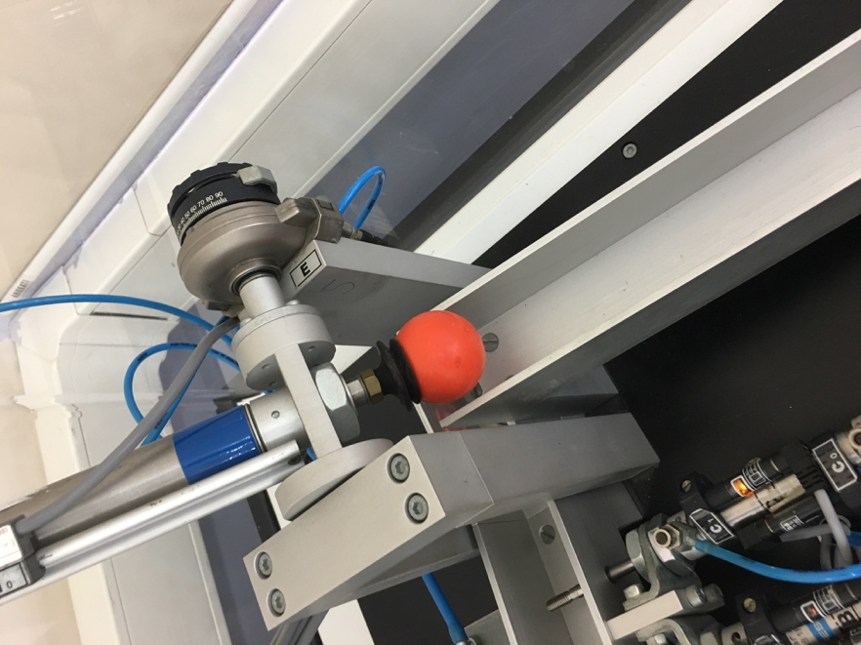

After that, the ball will roll down to the next sensor which after detection will activate the piston which will push up the branch and make the ball roll to the starting point.

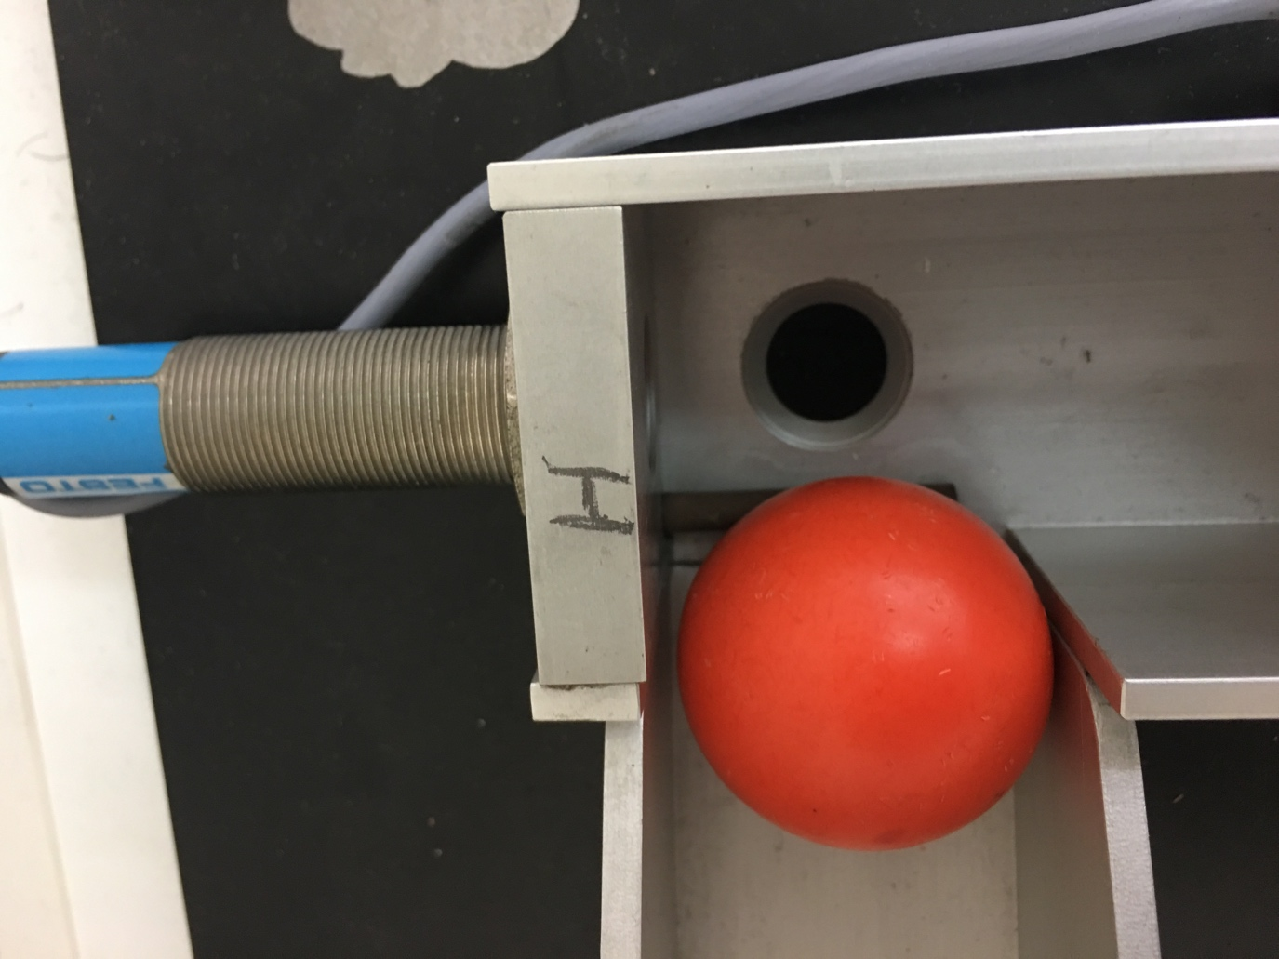

During my work with this system I’ve noticed that there are software and hardware factors which could affect the system. In my opinion the most common problem which should be mentioned in **software** part is problems with time delay (timers TON). The sing is, that if we imaginary split up our system on 3 parts (Starting point till vacuum, movement till “H” sensor and trip of the ball from “H” sensor to starting point) we will notice that we have to follow exact sequence. If we will not do it, our system will give us a wrong response and as a result will stop. That is why it’s so important to write a correct Ladder diagram and especially set the correct time (TON). What takes the **hardware** part, I could say that the material and weight of the ball is crucial in our case, because the speed depends on this factors. Type of sensors is important as well, because some of them could detect wood, another one could deal with metal and etc… So we have to be confident with what we are doing and where we will use our system. Of course pistons, pneumatic system could be air controlled or liquid controlled, each of those systems has their pros and cons, in our case we use air controlled system (the speed of response is depends on the pressure of the air and etc…).

Now let me show you some cases which I mentioned.

First one – the material of the ball is soft, as a result the piston could press it and the sequence of the system will be damaged.

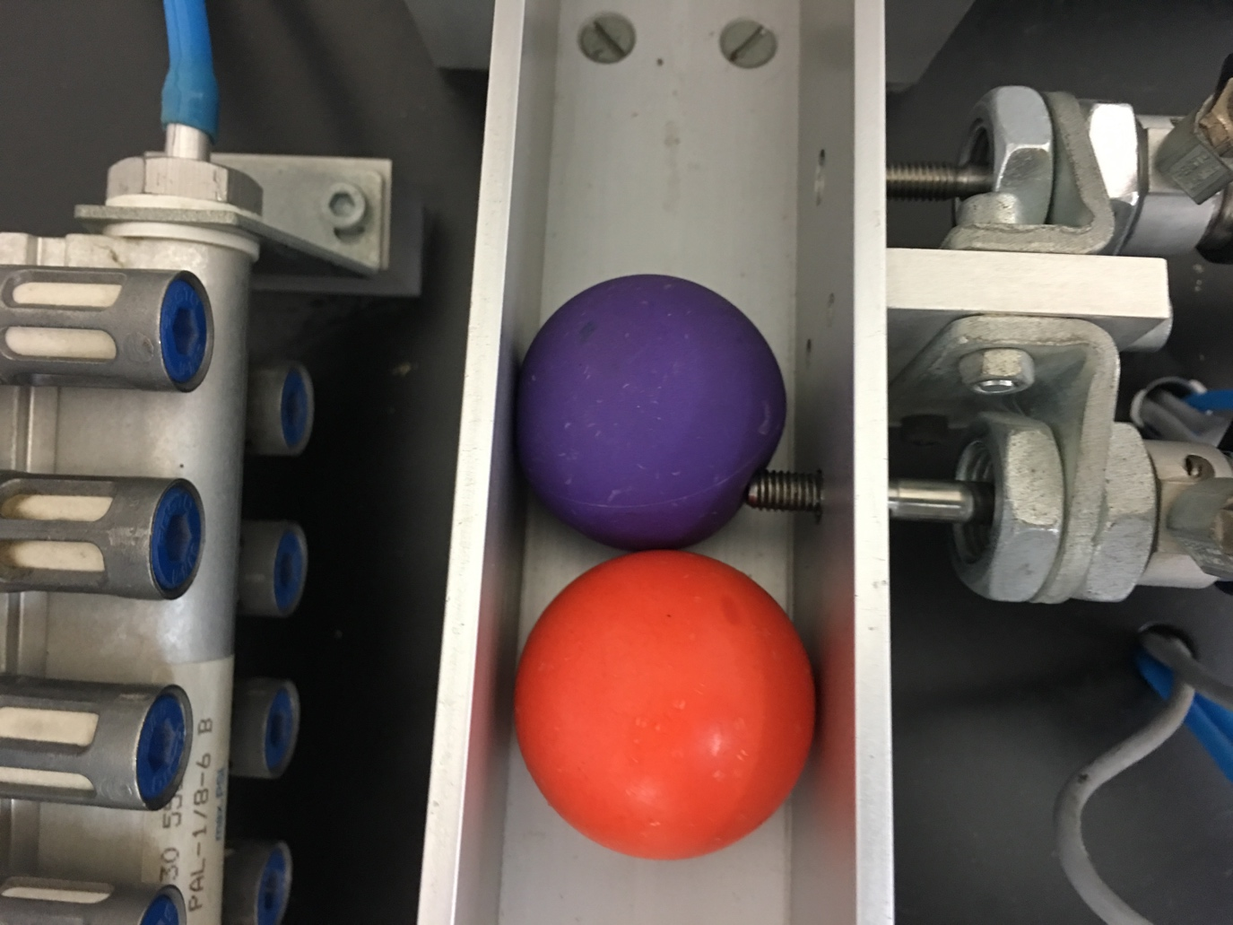

Second one – the weight of the ball could be not enough to cross over the small step, as a result sensor “H” will not detect the ball. By the way, that is why it’s necessary to set all possible conditions in software part, because if we do not set a sensor, the branch will move even without the ball, and it could cause another problems, we will see it on the next picture.

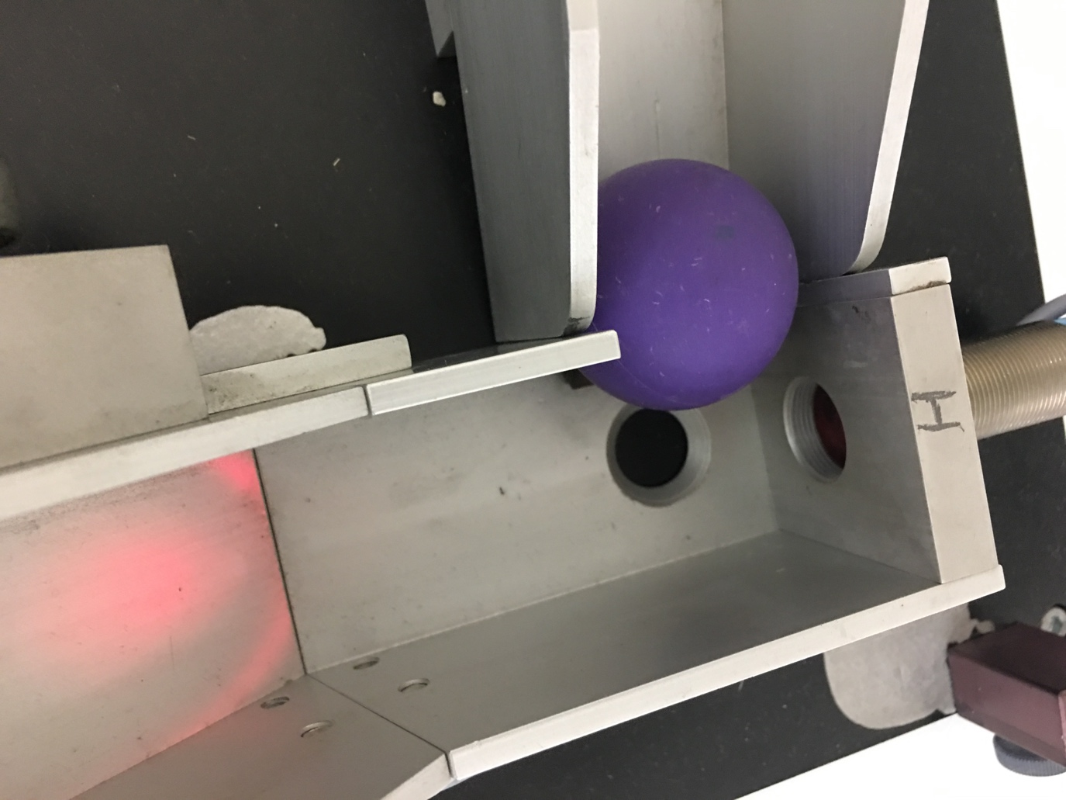

Here is the problem with bad software part and not enough weight of the ball, as a result our process is completely stopped.

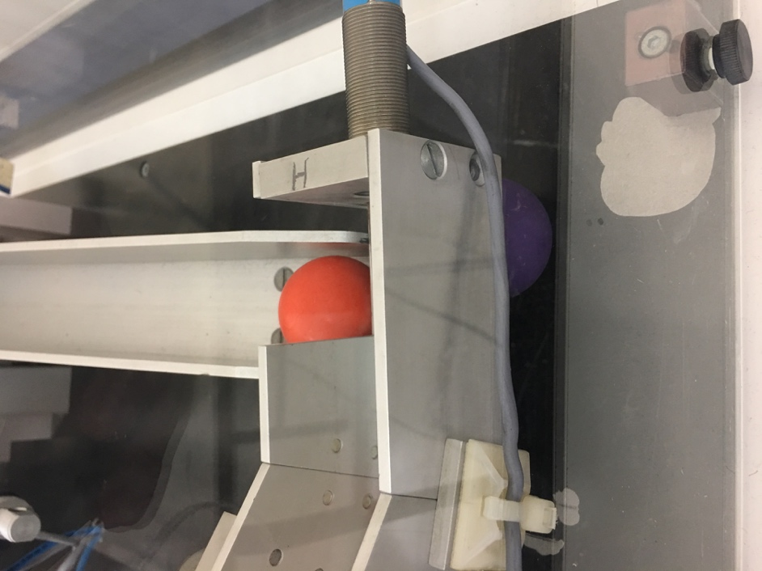

In addition:

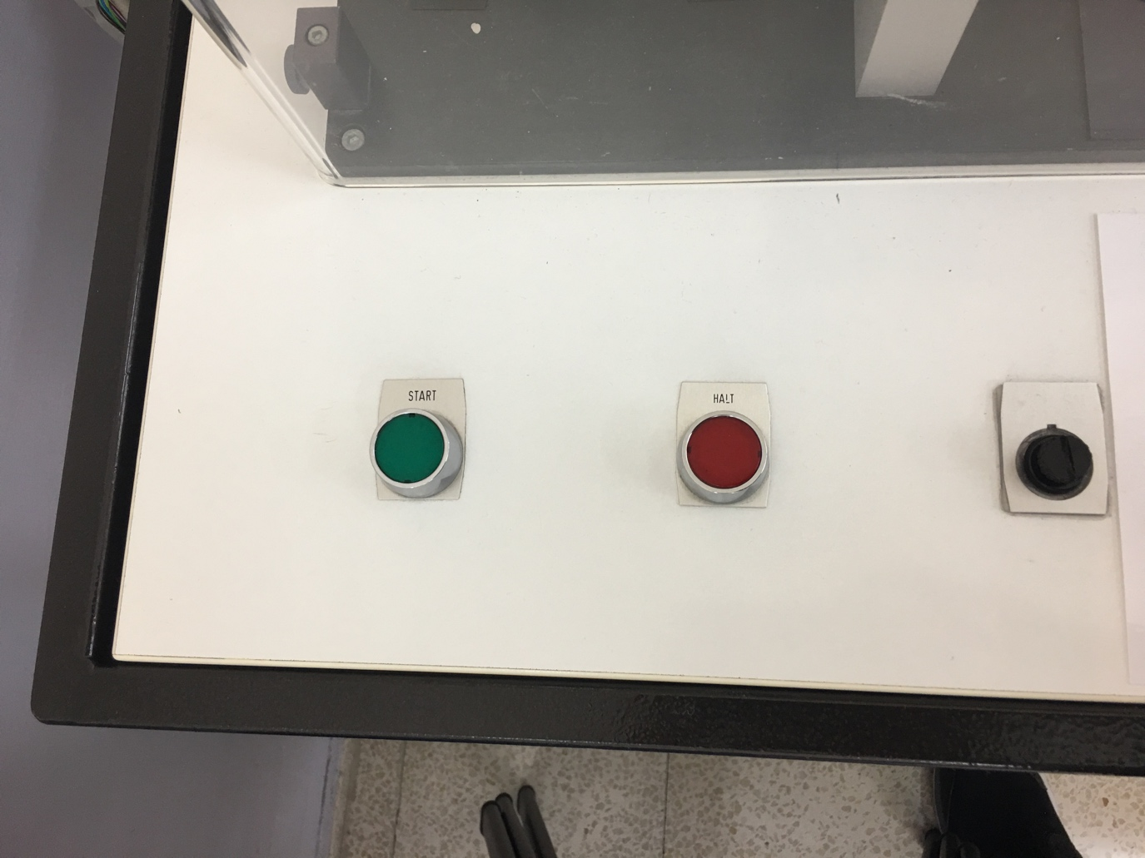

We can see START button, STOP button and fuse, for protection of our system.

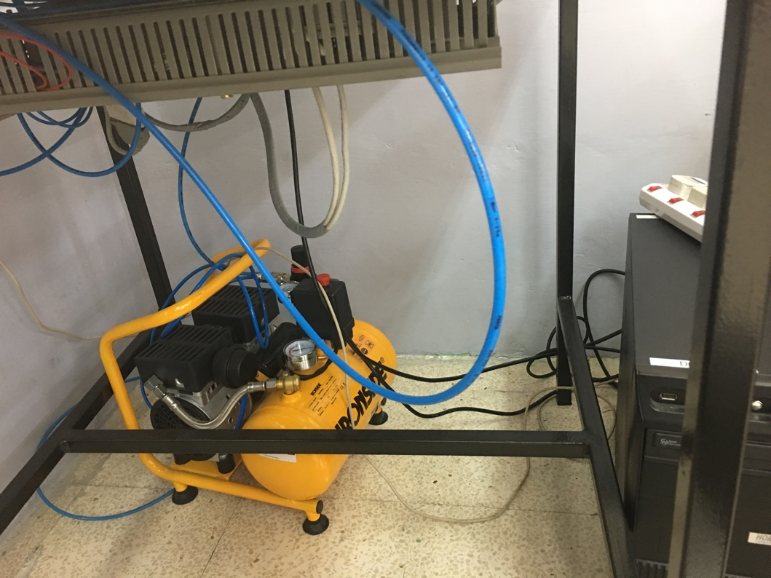

It’s a generator of the air for our system, it makes the pistons work and vacuum work.

**Repeatedly work of the program:**

Our program is just a sequence of actions according to special conditions (sensors). We could make it repeats as much times as we want. In case of our system, we had to add an extra rung which starts our system from the beginning at the point when specified conditions are reached. At the beginning and in the end of the Ladder diagram you could see the necessary flags which set this conditions and makes the system to repeat the sequence again and again.

**Question 5:**

To begin with, let me mention the most possible hazards in this system:

1. Pistons – they move fast and if your hand will be in wrong place it could damage it;
2. Moving of the branch – same situation as with pistons;
3. Air pressure – if the pressure will be to high the tubes could disconnect and the force of the air will damage the persons our any soft objects in the radius of it’s action;
4. Material of the system – for example if we use our system in very cold or hot environment, and suddenly we touch it, our skin could be damaged as well;
5. Vacuum – for example, if the configuration of the vacuum is wrong and the pressure is to high, it’s better not to put your hands or any objects under it.

All mentioned hazards are not crucial or critical in our case, and in most cases the safety factor in our system is depends on the person which use the system, but still, there is a lot of areas which could be improved.

Here is a picture of our system.

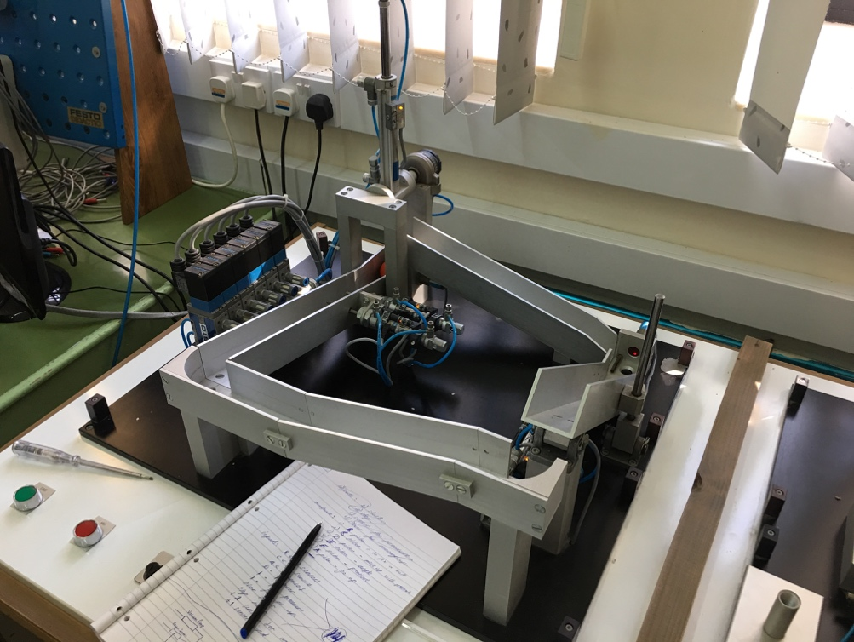

As we could see, there is no any borders or restrictions or warnings. You could touch and put your fingers whenever you want, and for sure it’s not responsible and not correct. As a summary, we could say that there is no dangerous for life but if we talk about safety of the system in general, the safety level is low.

**Question 6:**

Now let me start from the photo of our system after some time.

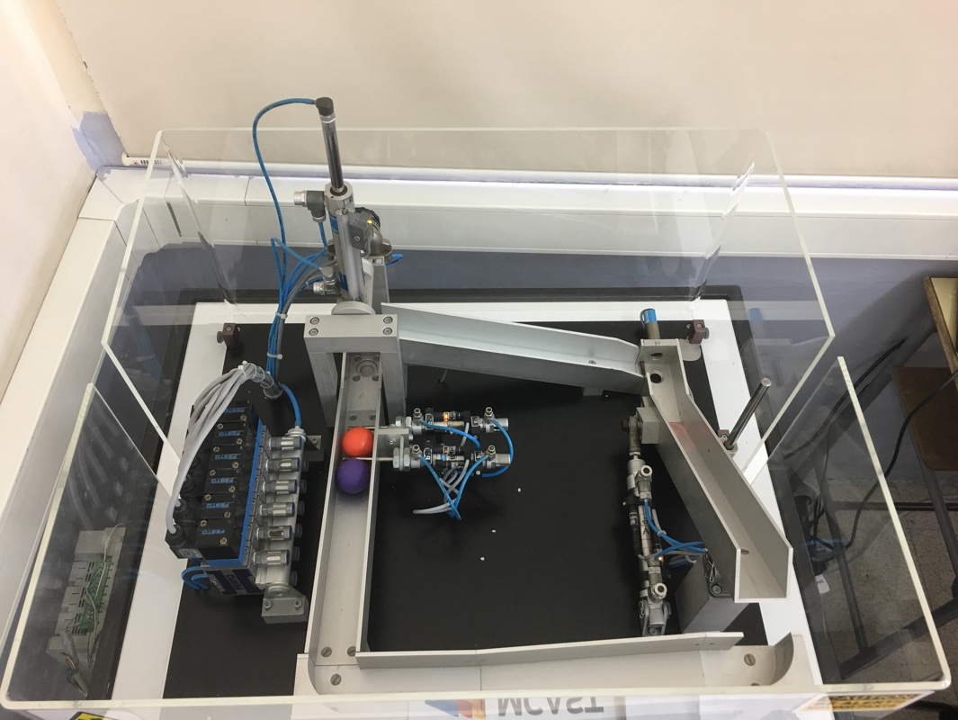

As you could notice, our system has a safety border now. This improvement protects operator from sudden contacts with system and prevent getting apart objects in the system.

In my opinion there are more things which could be changed, to make this system safer:

1. The branches with the balls could be closed, it will prevent jumping out of the balls;
2. In cooperation with pistons could be connected additional sensors which will detect human’s hand and will not allowed system to operate;
3. Emergency STOP could be implemented. Emergency STOP is usually a hardware part, which works independent from the system, but in emergency situation it effects whole the system and stop all the processes;
4. We could add a pressure control, to control our valves and pistons;
5. Some of the angles could be covered with a special case, to reduce their sharpness;
6. The system could be contained in the plastic cage or box which will close the system and if you open the cage during the working process – the system will automatically stop, to prevent probable damages of the operator;
7. The materials of the system could be made of wood and all wires could be isolated and fixed far from the system to prevent a shortens.
8. As an addition option we could implement a mechanical manipulator to pick up the balls inside our system, as a result the communication with system will be minimal and the risks will be reduced as much as it possible.
9. The sound and light alarm could be added as well.

**Question 7:**

Last summer I had a practice in Playmobile company. I’ve seen a lot of different systems and have learned a lot of information about those systems especially about safety factor.

Let me show you one of the systems, which I’ll be talking about.

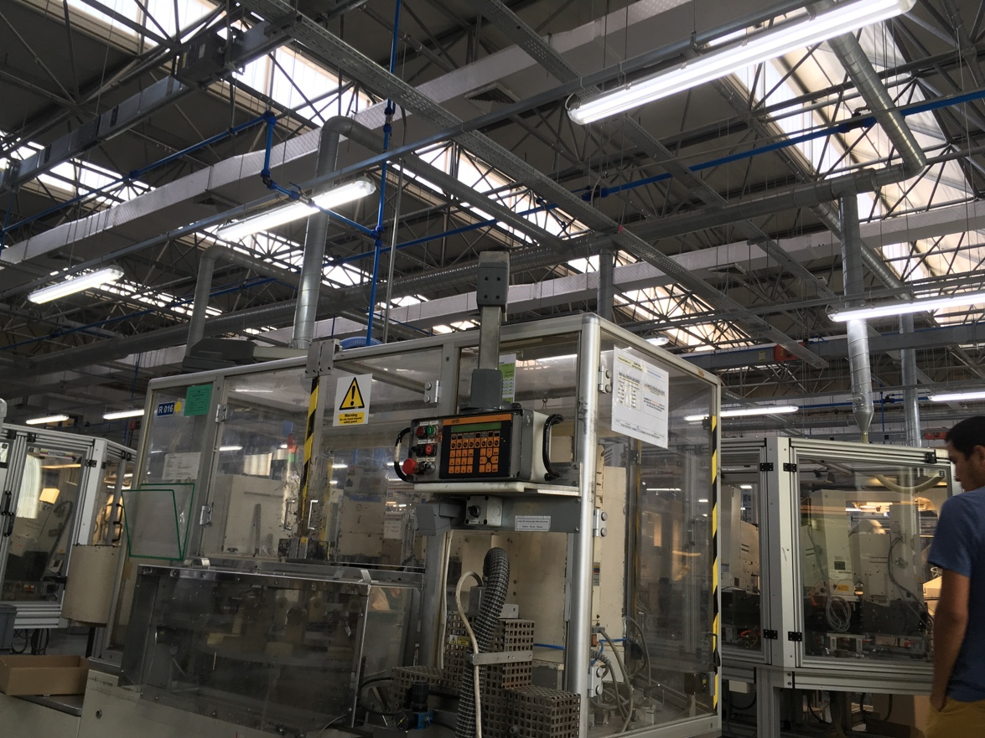

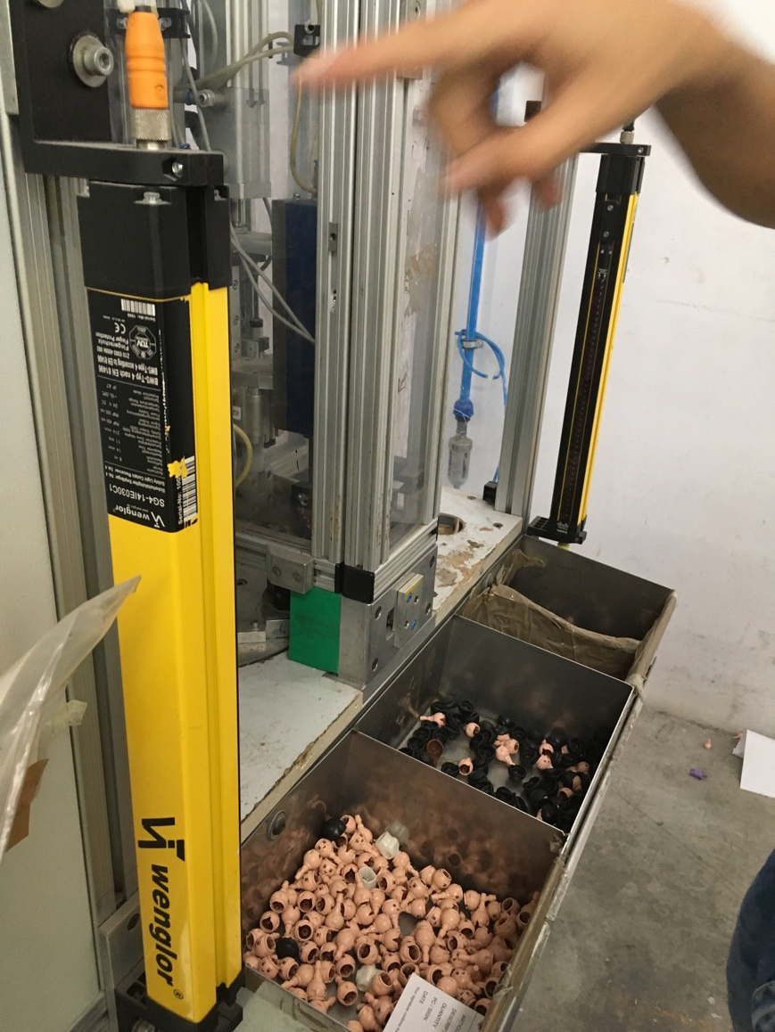

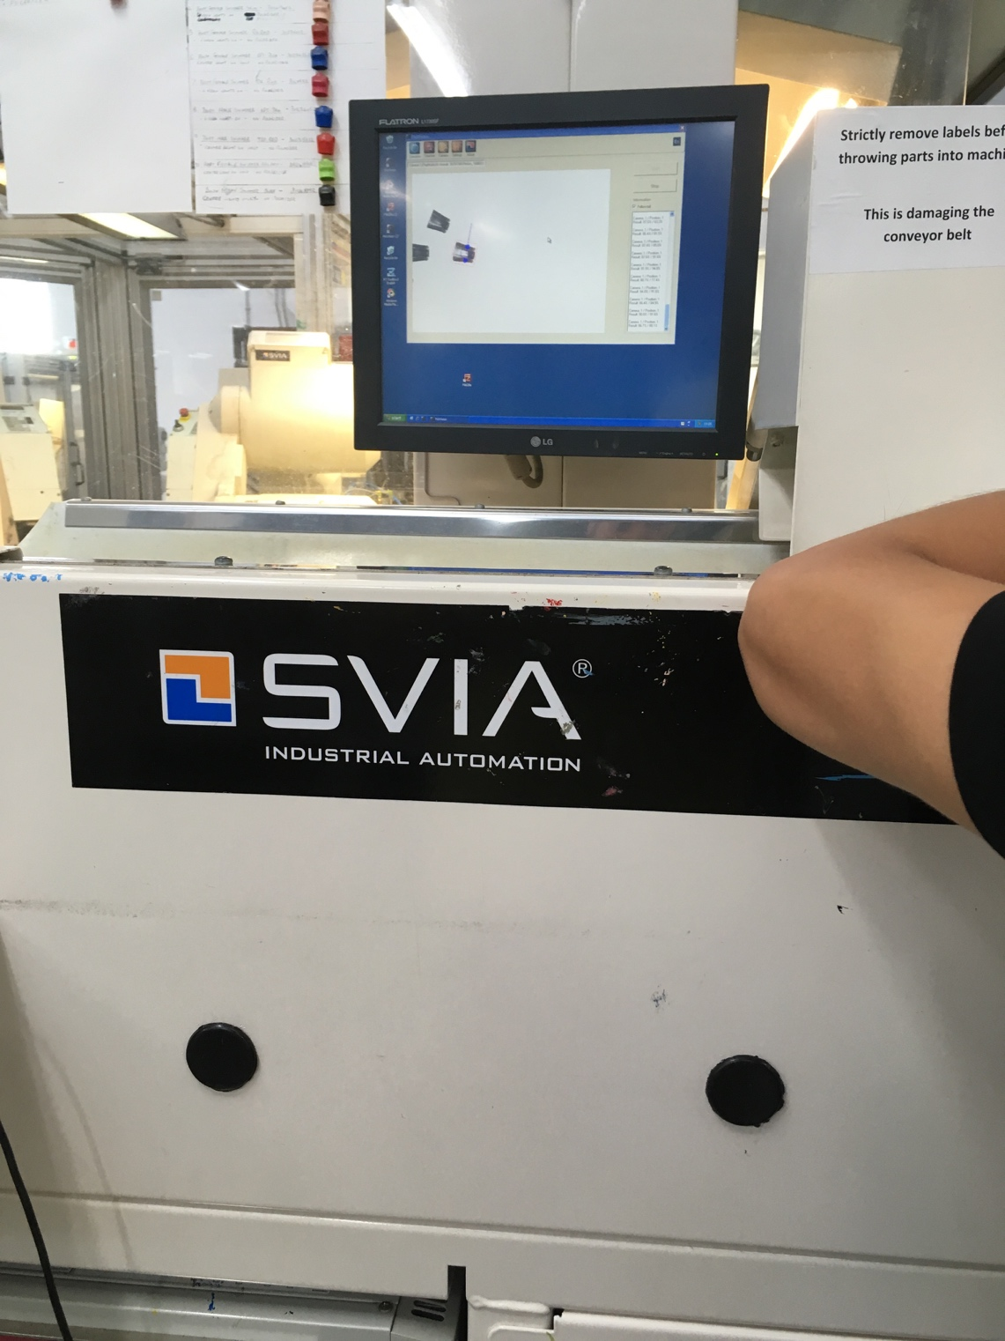

This system has to check, paint and sort the details which were produced and added inside this system before.

Let me describe the process. There are special seats/places for the details, the system automatically takes the detail (by automatic manipulator) and put it on the correct place, then when the sensor detect this detail it will activate painting, after that the detail is putting on the conveyor belt after what it goes in the basket.

As you could see, here is the same principle as in the our system. It uses the sequence and sensors, but in our system we were working with pistons and sensors – but in this system they use some pneumatics, painting equipment and another type of sensors, but the main idea is same. The main thing is sequence.

Now let me discuss the safety regulations, factors related to this system. To begin with all this systems are protected, they have a special cage, and nobody cant put their hands inside during the working process.

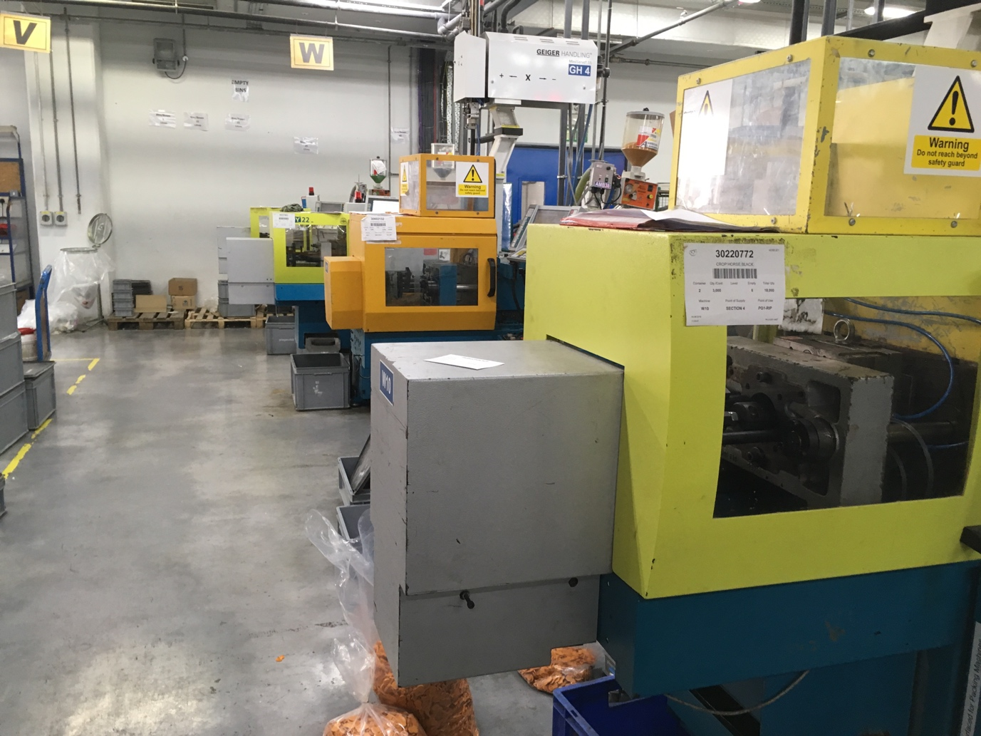

Around the system you could see an additional cage, which will not allowed you to enter inside the system. To open the cage you have to follow a special sequence: press the button to stop the system, another button to open the door and open the door with a special key. By the way, when the operator is inside the system, the door can’t close, even manually and the system will not run, even if the operator has a special remote controller and press a START button – the system will not run because the apart object is inside. As any other system in industry this system has an emergency stop, but not 1, it has 3 buttons, which is located around the system, so you could stop it in any time.

In my opinion this system has a very high level of safety, because there is no contact with around world, everything is working inside the cage and nothing will not work if someone enter the cage, so there is no risks for operator.

As an improvement I can suggest better cage materials, to make them stronger and apart of using the key, to use a code lock, with combination of 4 digit numbers and in addition to the all regulations which I mentioned, to add a password to start the system. From my point of view it will be one of the safeties systems.